Maroun Najem – 202210166
GitHub: https://github.com/maroun-202210166/midterm.git

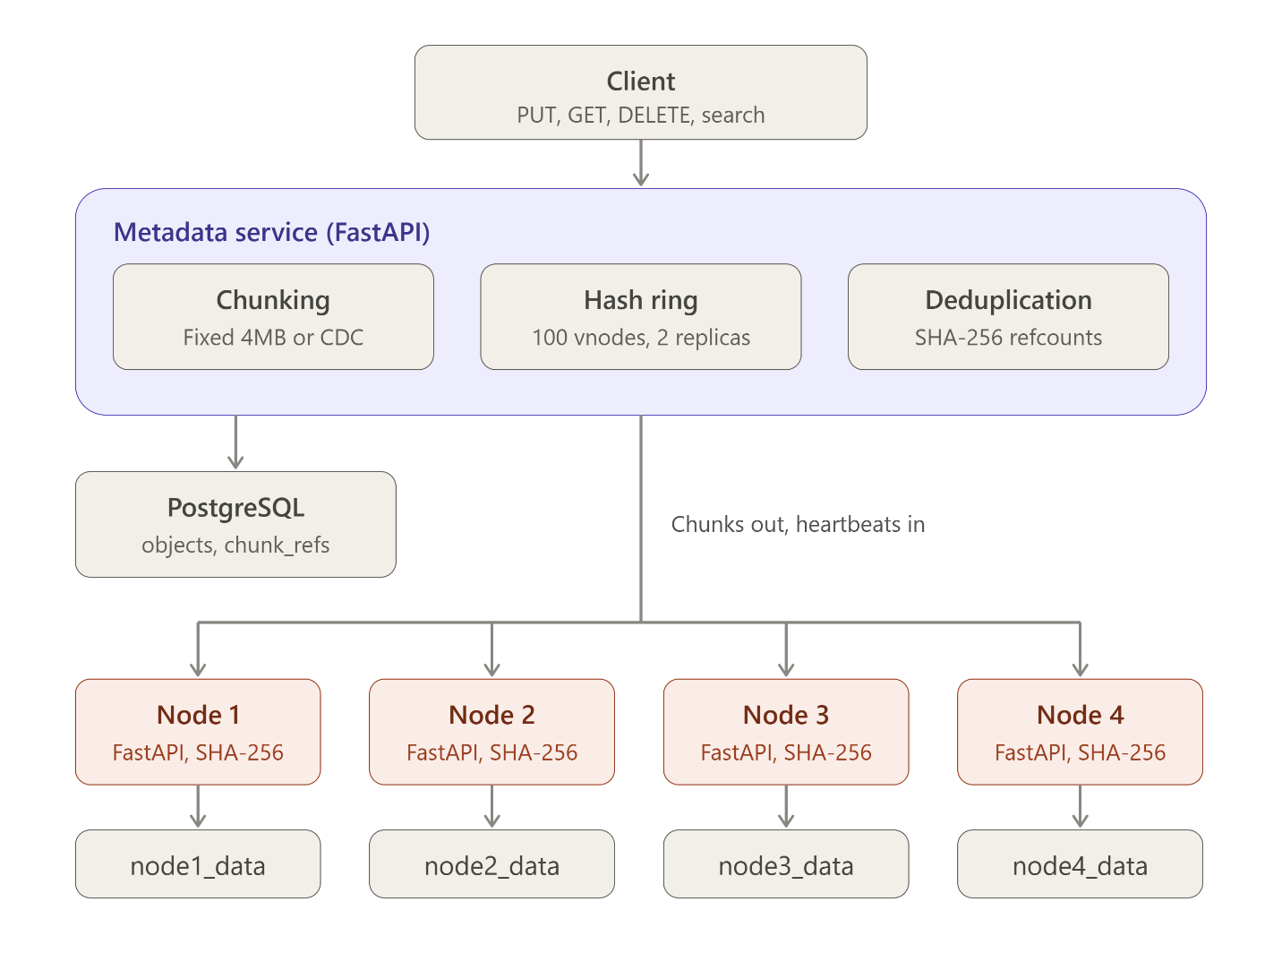

Task 1: Environment Setup
1- Python and virtual environment
- Python 3.10.11 installed
- venv created with python -m venv venv
- activated with venv\Scripts\activate.

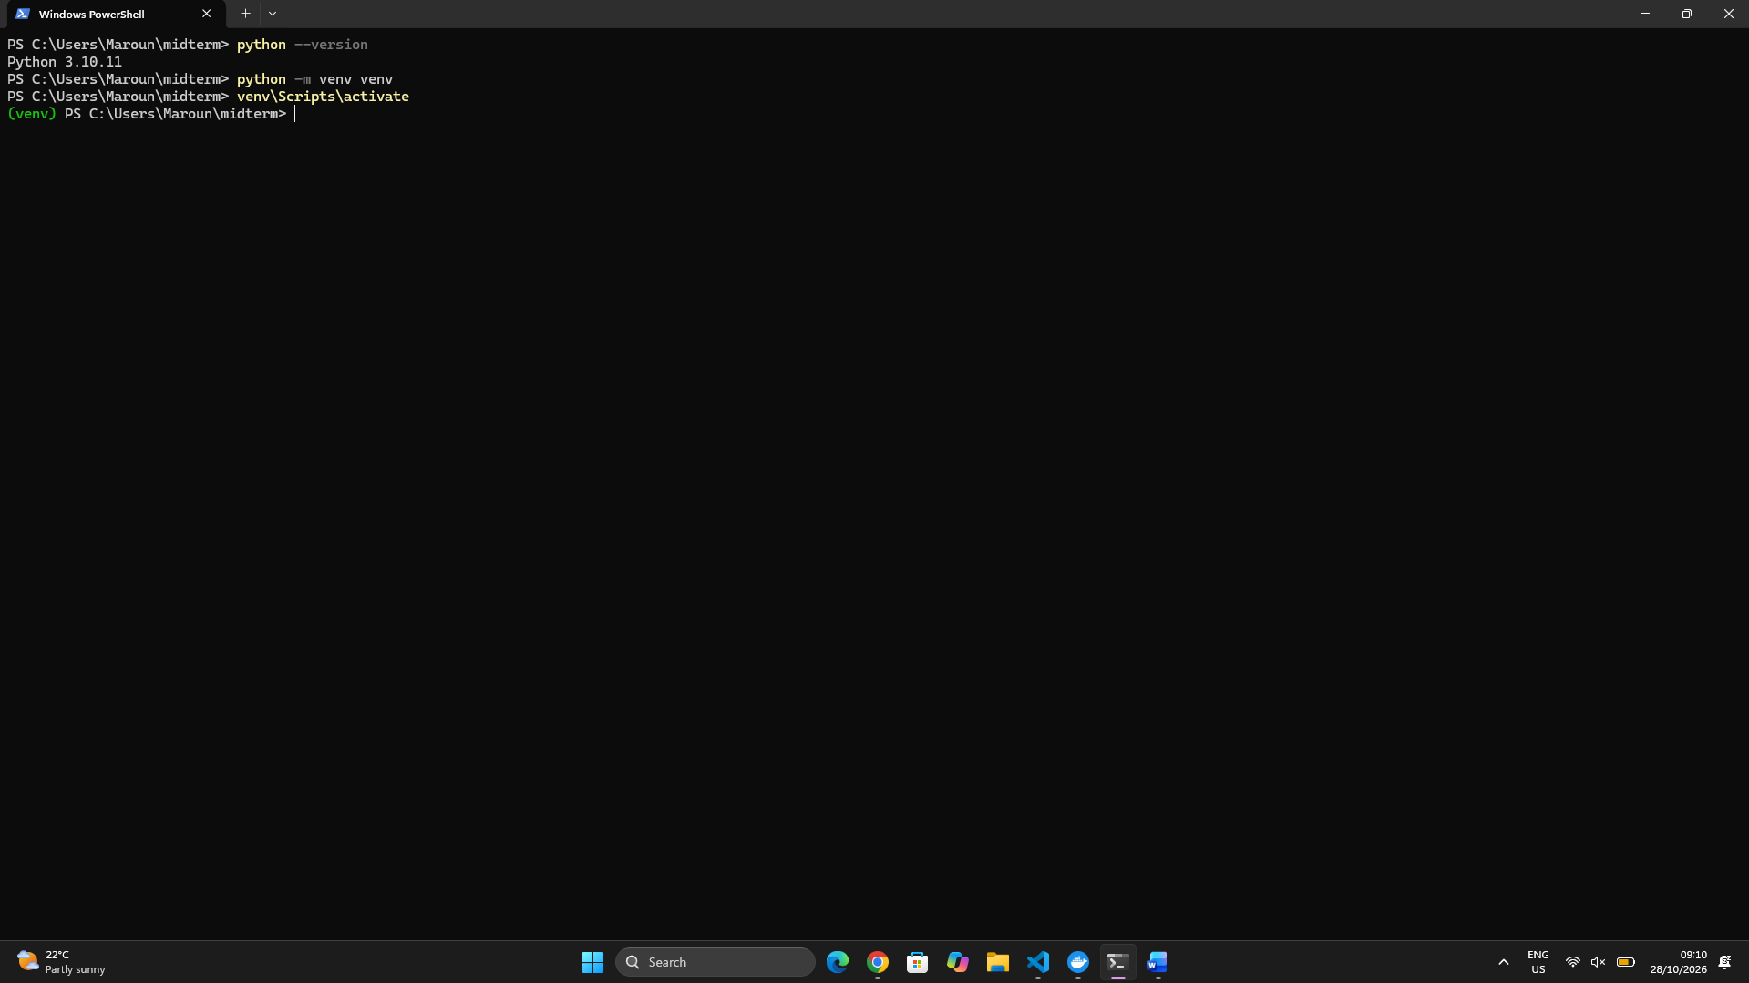

2- Version control:


3- Docker and Kubernetes
Docker Desktop installed, Kubernetes enabled with the kubeadm method, and verified with kubectl get nodes.

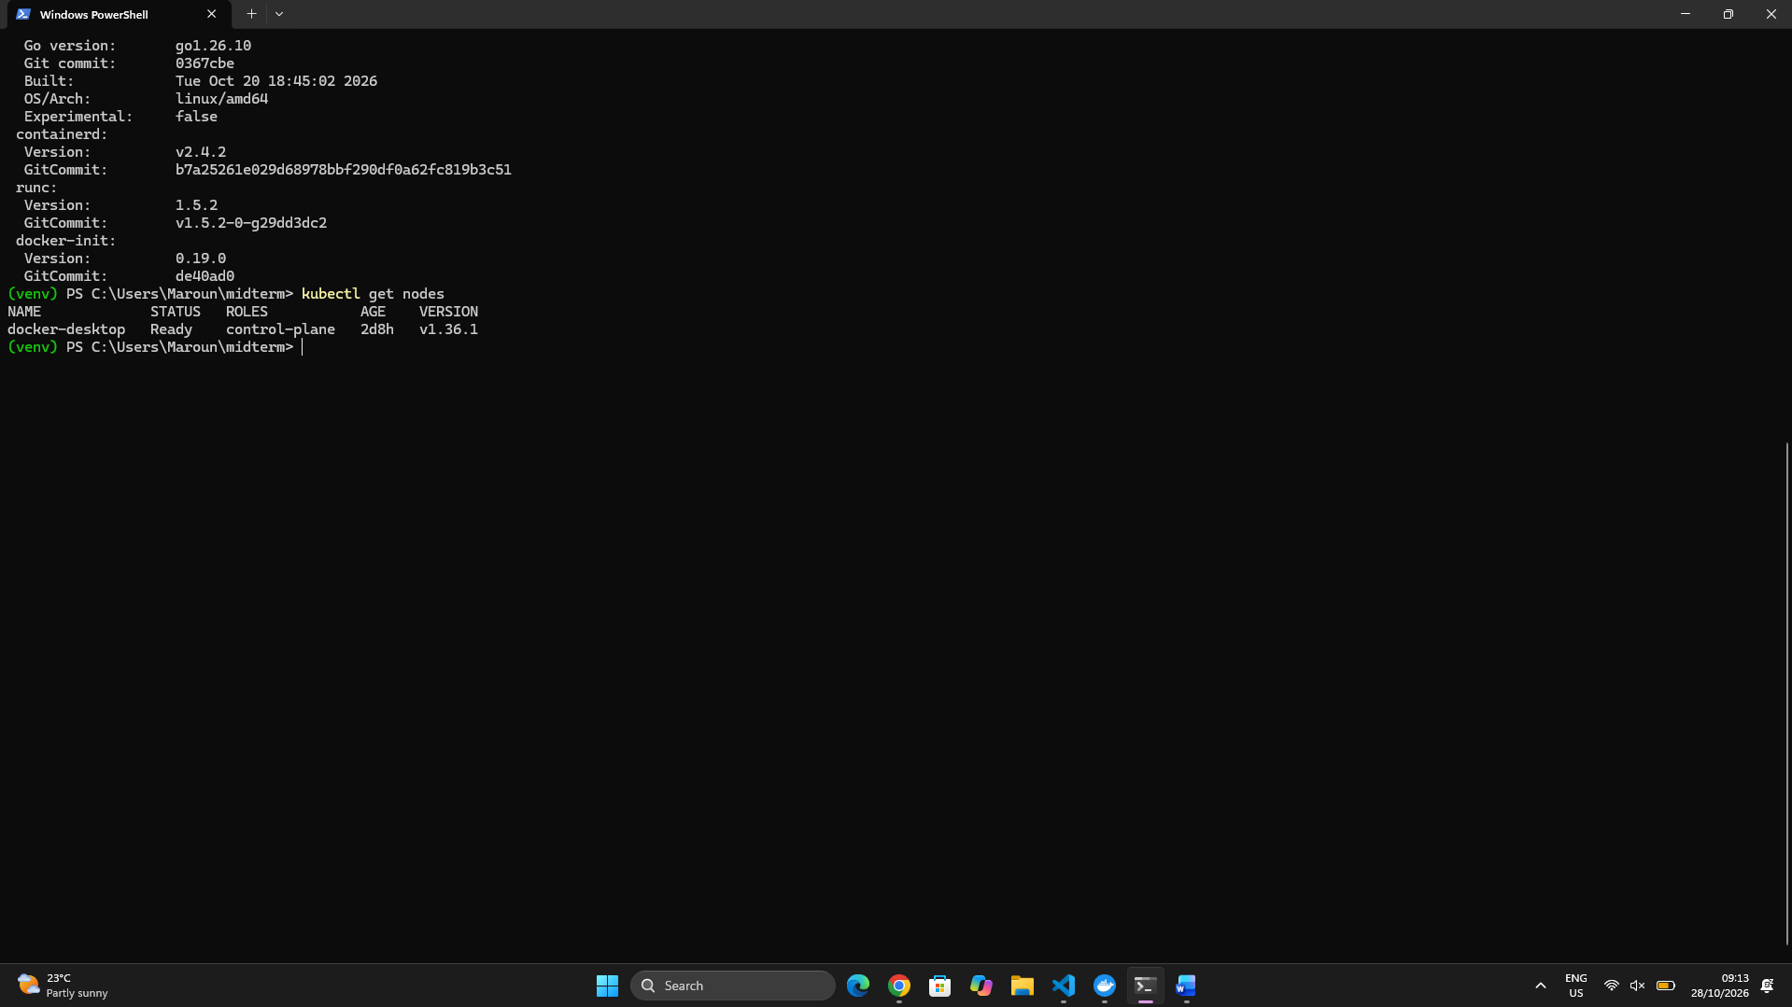

4- Separate storage per node
Four containers (node1 to node4), each with its own Docker volume mounted at /data, defined in docker-compose.storage.yml

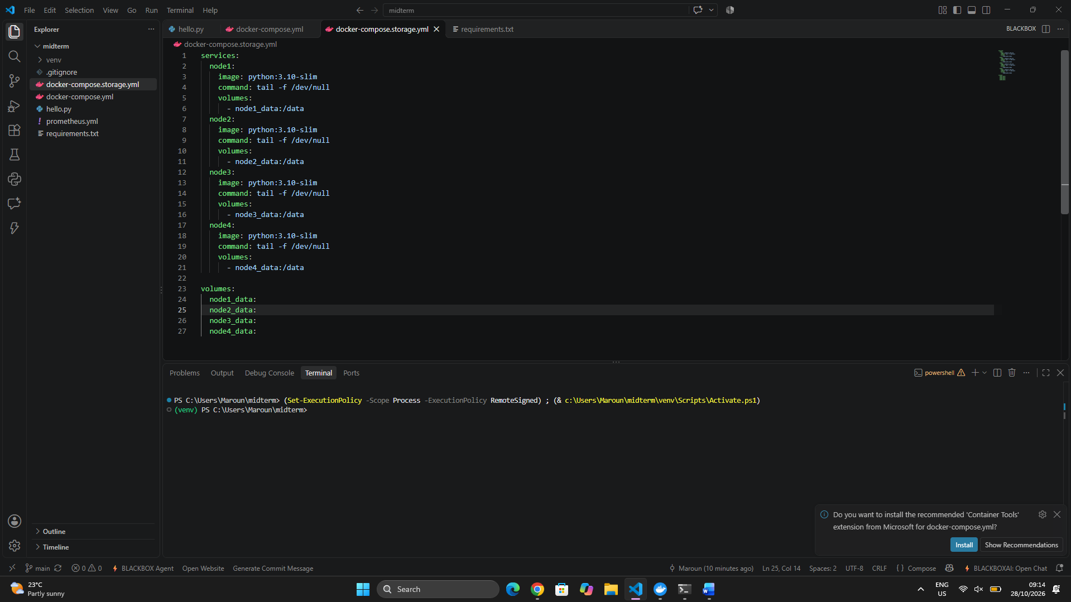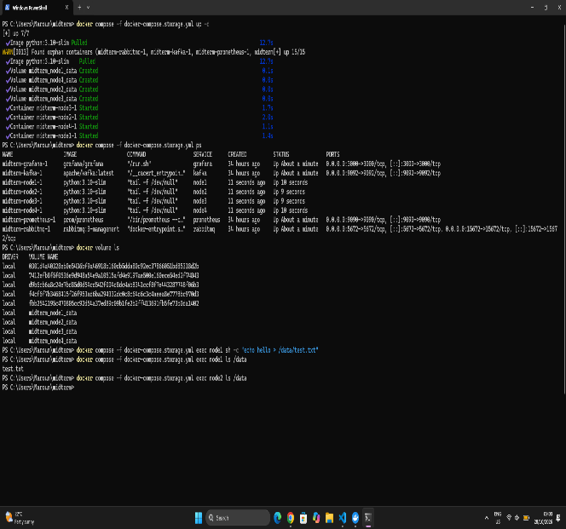

The environment is ready: Python, version control, Docker, Kubernetes, and four isolated storage nodes.

Task 2: Storage Node Module
1- Design
  - Each storage node is a FastAPI service exposing PUT, GET, HEAD and DELETE on /chunks/{hash}.
  - The chunk ID is the SHA-256 hash of its content. Chunks are stored on the node’s own volume at /data/<first 2 hex chars>/<hash>.
  - A small metadata service receives heartbeats and tracks which nodes are alive.
  - Files: storage_node/app.py, metadata_service/app.py, Dockerfile, docker-compose.storage.yml.
2- Deployment: 4 nodes in separate containers
- Built with docker compose -f docker-compose.storage.yml up -d --build.
- Each node has its own container, its own port (8001 to 8004) and its own volume from Task 1.
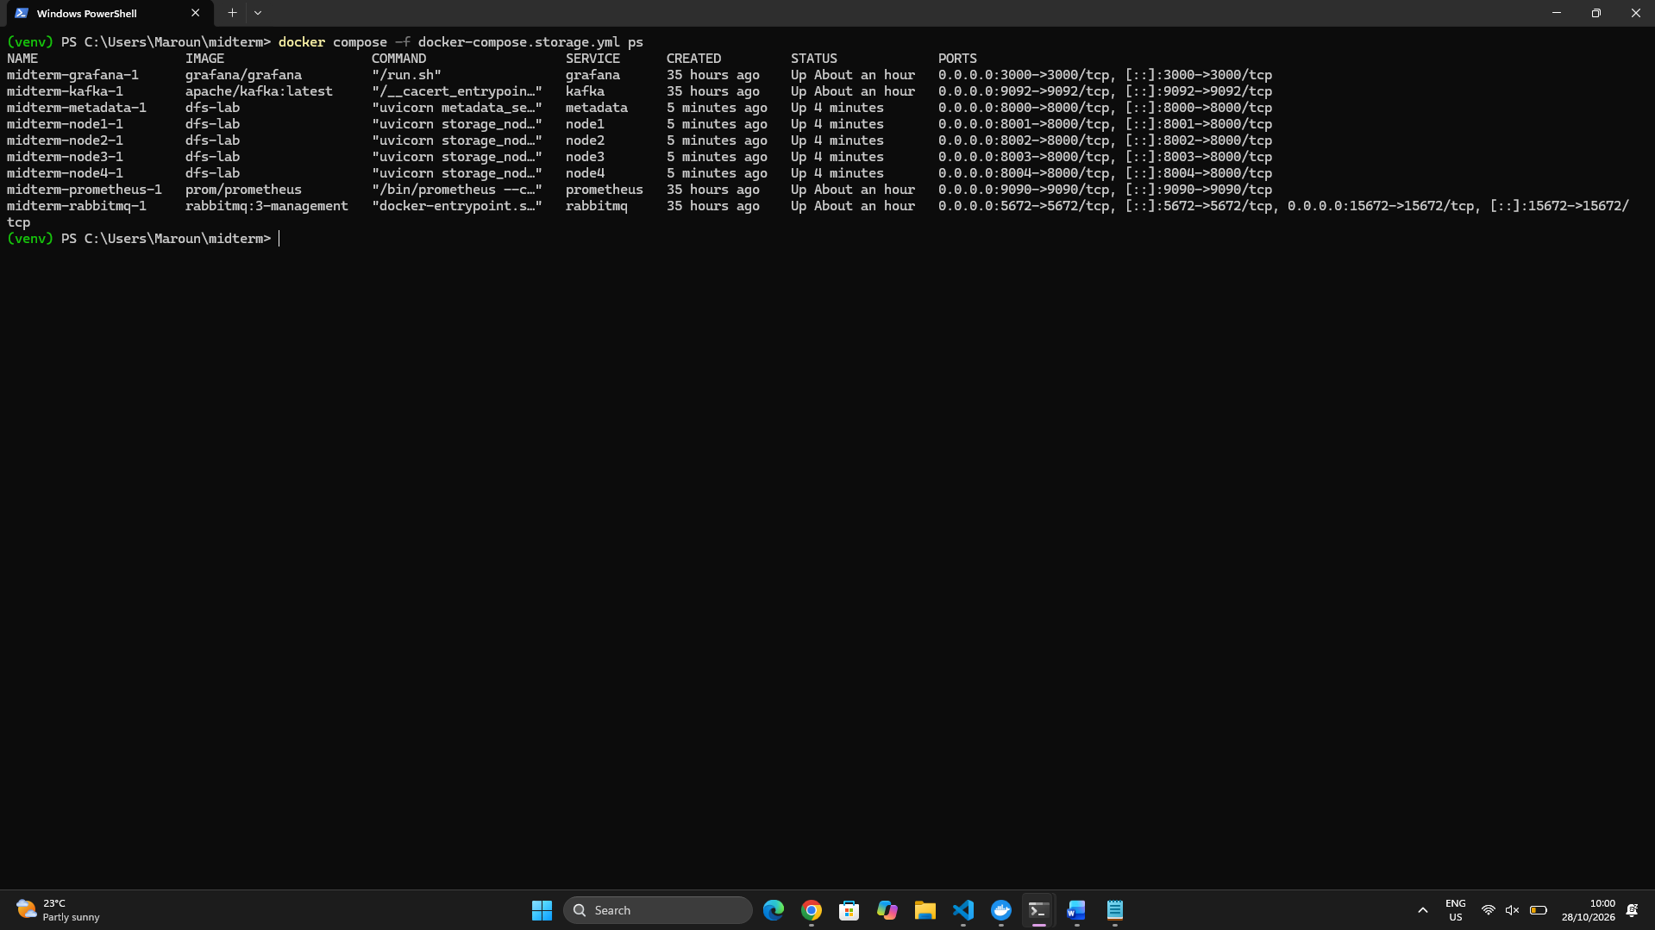

3- Heartbeats
- Every 5 seconds each node sends its node ID, free space and chunk count to the metadata service (POST /heartbeat).
- A node counts as dead if no heartbeat arrives for 15 seconds.
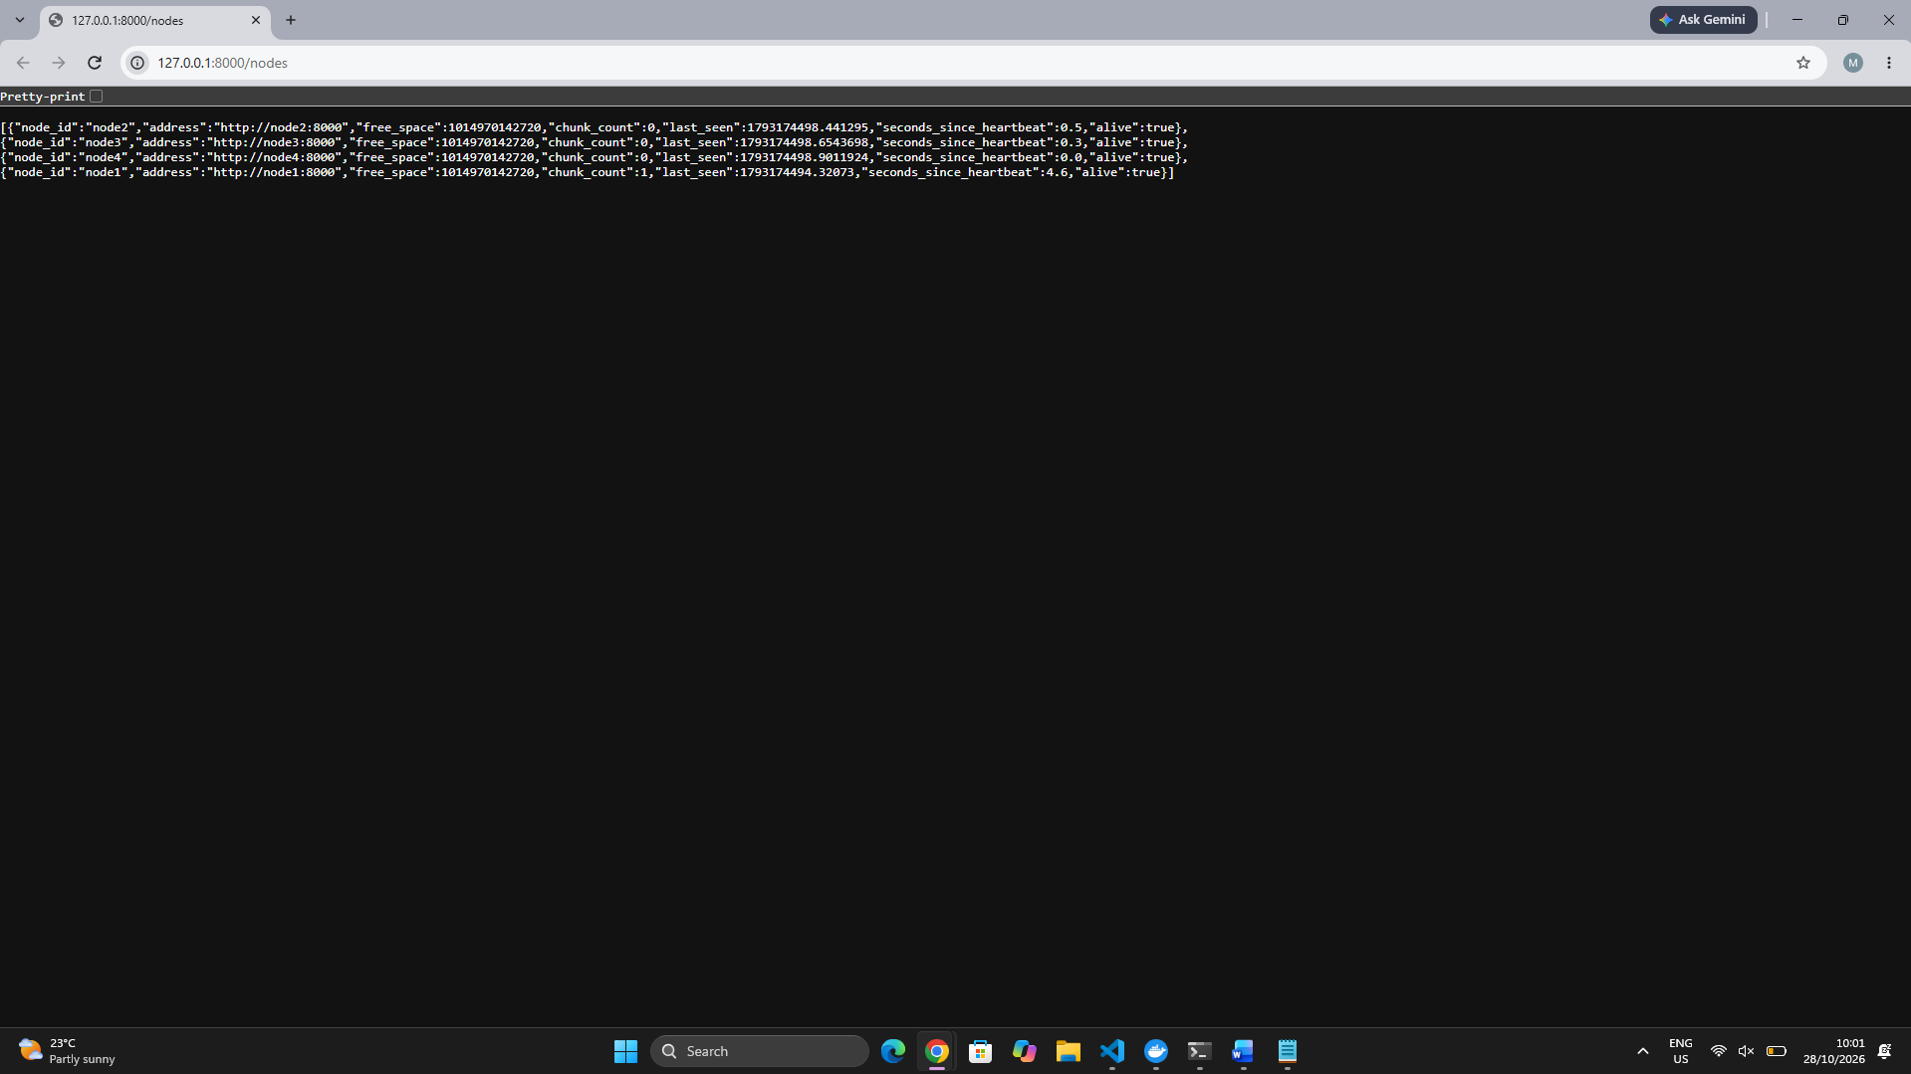

4- API test
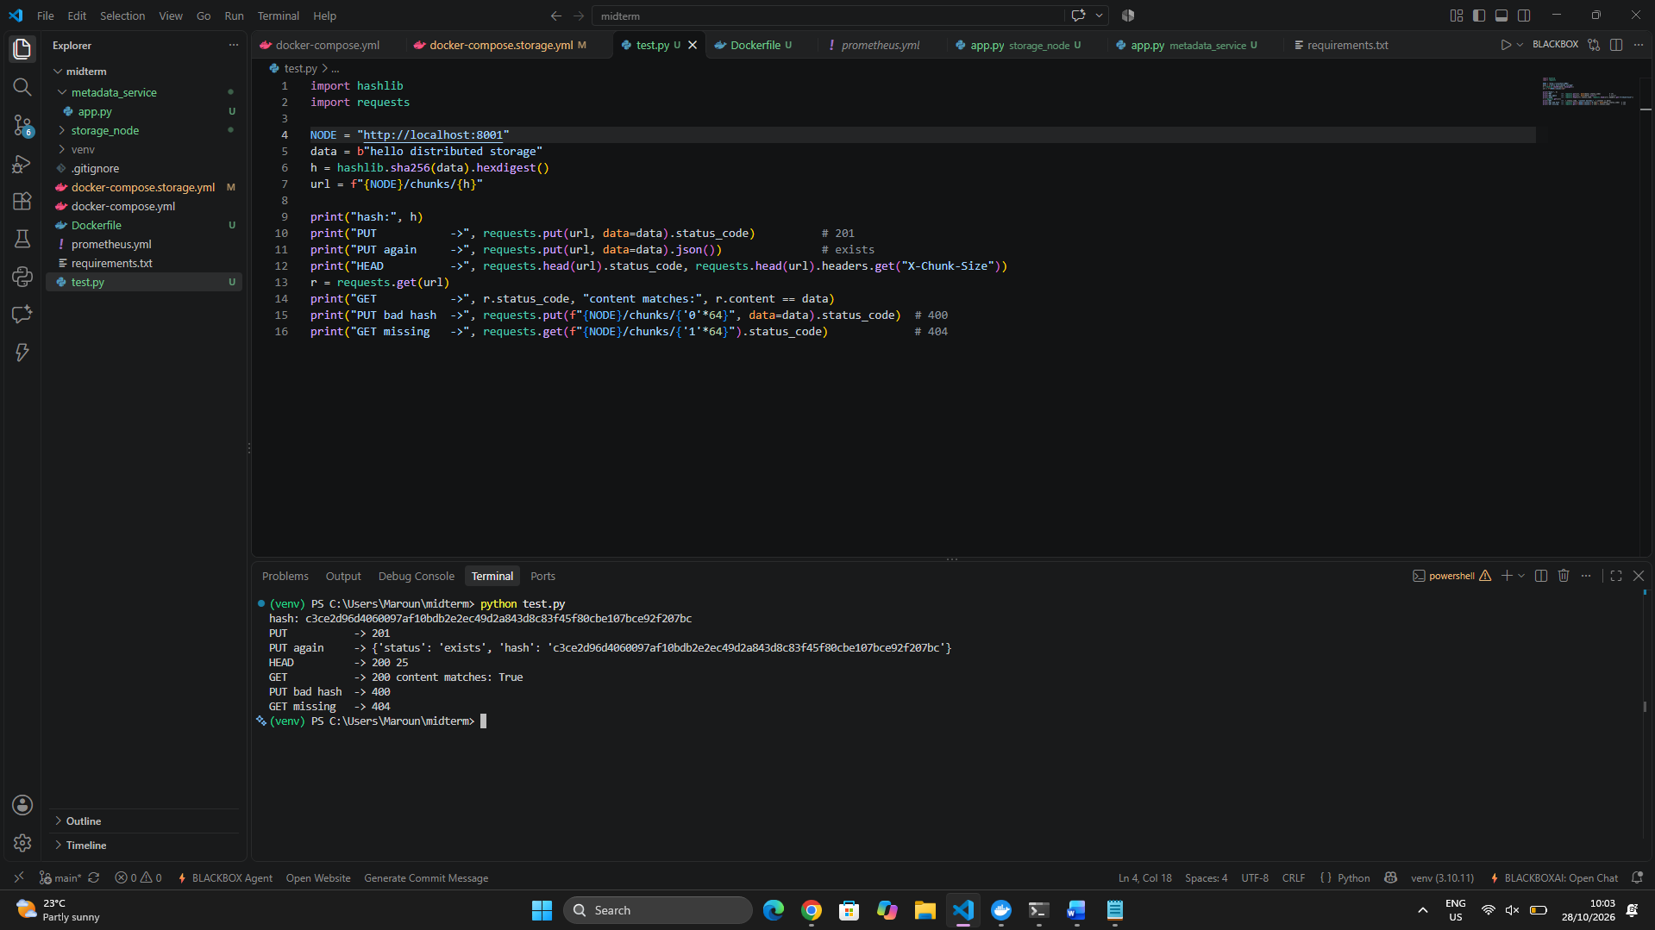

5- Integrity check on read
I modified a stored chunk on disk, and GET returned 500 chunk corrupted. The node re-hashes the data on every read and refuses to serve corrupted chunks.
Corruption test. Use the hash printed by the script, and replace HASH and HA (its first two characters):
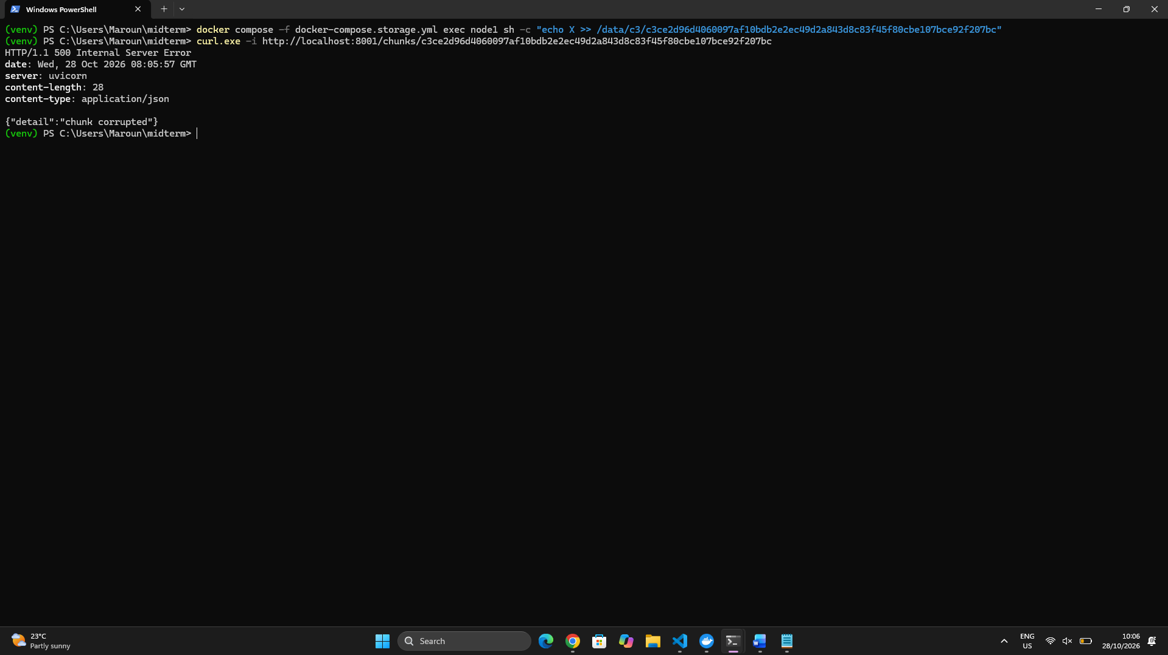

6- Delete
DELETE removed the chunk, and HEAD then returned 404.
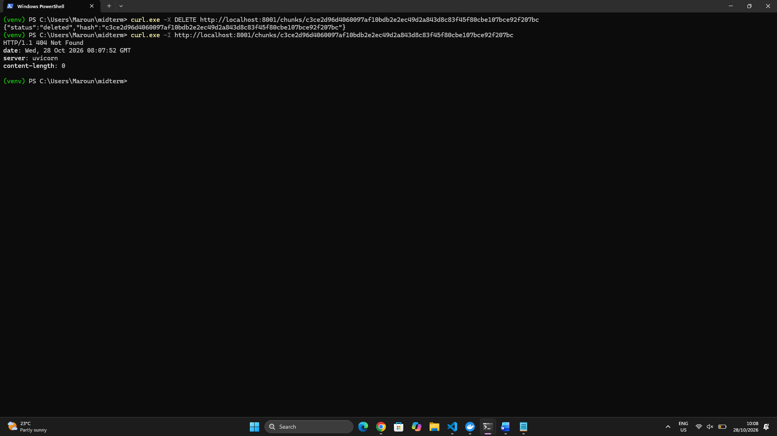
7- Failure detection
I stopped node3 with ‘docker compose -f docker-compose.storage.yml stop node3’. After 15 seconds it showed "alive": false in /nodes, and after starting it again it returned to true.

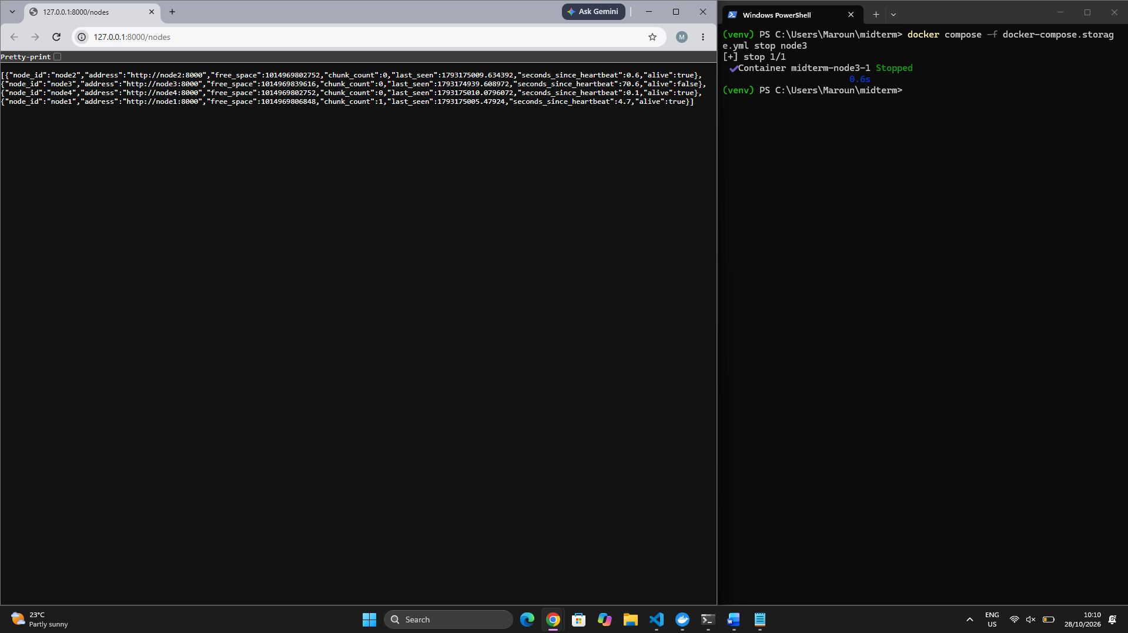

8. Challenge (optional but worth a short paragraph)
- The metadata container didn’t start at first, which made /nodes unreachable. I found the cause by checking docker compose ps -a and docker compose logs metadata, fixed it, and rebuilt. Short problems like this show real work.
Conclusion
Four independent storage nodes now store content-addressed chunks, verify integrity on every read, and report their health through heartbeats. This is the foundation for consistent hashing, replication and erasure coding in the next tasks.

Task 3: Implement the Metadat and Placement Module
1- Two strategies were implemented in metadata_service/chunking.py:
- Fixed-size chunking: the file is cut every 4 MB. It is simple and fast, but inserting even one byte at the start shifts every later boundary, so all chunks change.
- Content-defined chunking (CDC): a rolling (gear) hash is computed over the data, and a boundary is placed wherever the hash matches a bit pattern. Chunk sizes are between 16 KB and 256 KB, averaging about 64 KB. Boundaries depend on the content rather than the position, so a local edit only changes nearby chunks.

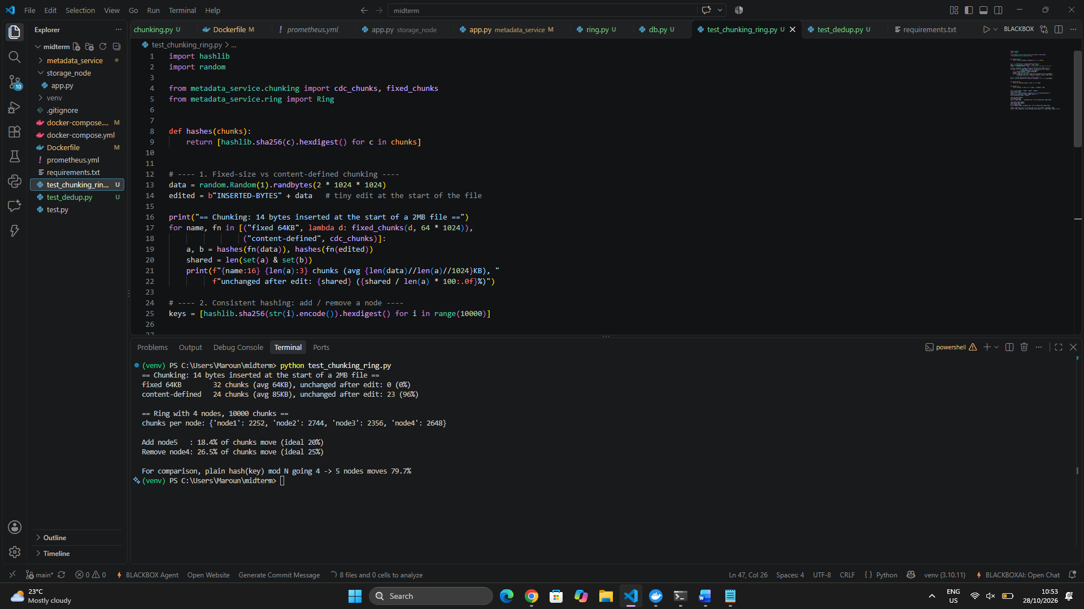

2- PostgreSQL runs as its own container, with a volume for its data. Two tables are used:
- objects: bucket, key, version, size, chunking mode, ordered list of chunk hashes (JSONB), creation date. The primary key is (bucket, key, version), so uploading the same key again creates a new version.
- chunk_refs: chunk hash, size, reference count, and the nodes that hold the chunk.

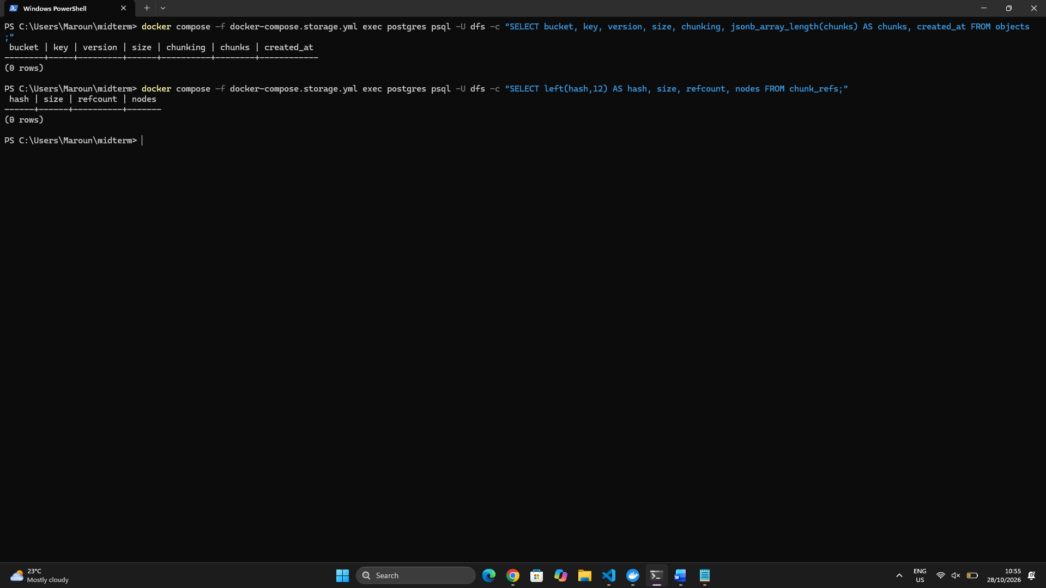

3- Implemented in metadata_service/ring.py. Each storage node is placed on the ring 100 times (virtual nodes) by hashing node#i with SHA-256. A chunk is mapped to the first 2 distinct nodes found clockwise from its hash, so each chunk has 2 replicas (REPLICAS=2). Virtual nodes spread the chunks evenly across nodes.
Distribution with 4 nodes and 10,000 chunks:
chunks per node: {'node1': 2252, 'node2': 2744, 'node3': 2356, 'node4': 2648}

4- The primary node of 10,000 chunk hashes was recorded before and after changing the ring.
Change | Chunks that move | Ideal
Add node5 (4 to 5 nodes) | [value]% | 20%
Remove node4 (4 to 3 nodes) | [value]% | 25%
Plain hash mod N (4 to 5 nodes), for comparison | [value]% | n/a

Explanation: with consistent hashing, a new node only takes over the ring segments right before its own points, so it takes a share of data roughly equal to 1/N from the others. With hash mod N, changing N changes almost every assignment, which would force nearly all the data to be moved. This is why consistent hashing scales.

5- Deduplication with reference counting.
Each chunk is identified by its SHA-256 hash. When a chunk is uploaded:
- If its hash is new, a chunk_refs row is created with refcount = 1 and the chunk is sent to its 2 target nodes.
- If the hash already exists, only the refcount is incremented, and nothing is sent to the nodes.
- On delete, the refcount is decremented, and the chunk is removed from the nodes only when it reaches 0.
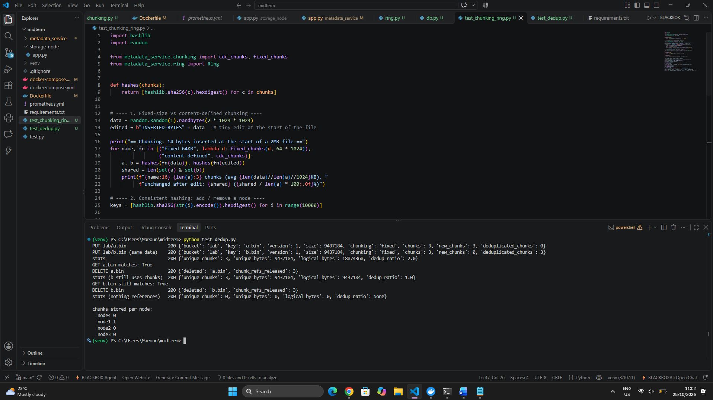

6- The system now splits files into chunks with fixed-size or content-defined chunking, stores object metadata and reference counts in PostgreSQL, places each chunk on 2 nodes using a consistent hashing ring with virtual nodes, and deduplicates identical chunks safely. The placement test showed that changing the number of nodes moves only a fraction of the data. Moving the data and repairing failed nodes will be done in the next task.

Task 4: Implement Redundancy and Recovery
1- Environment preparation
- Added zfec to the Dockerfile.
- Extended the metadata service with the replication settings (N=3, W=2, R=2) and the erasure-coding settings (k=2, m=2).
- Rebuilt the images and reset the volumes, so the test starts from an empty cluster.
- The /nodes output shows four storage nodes alive with zero chunks.

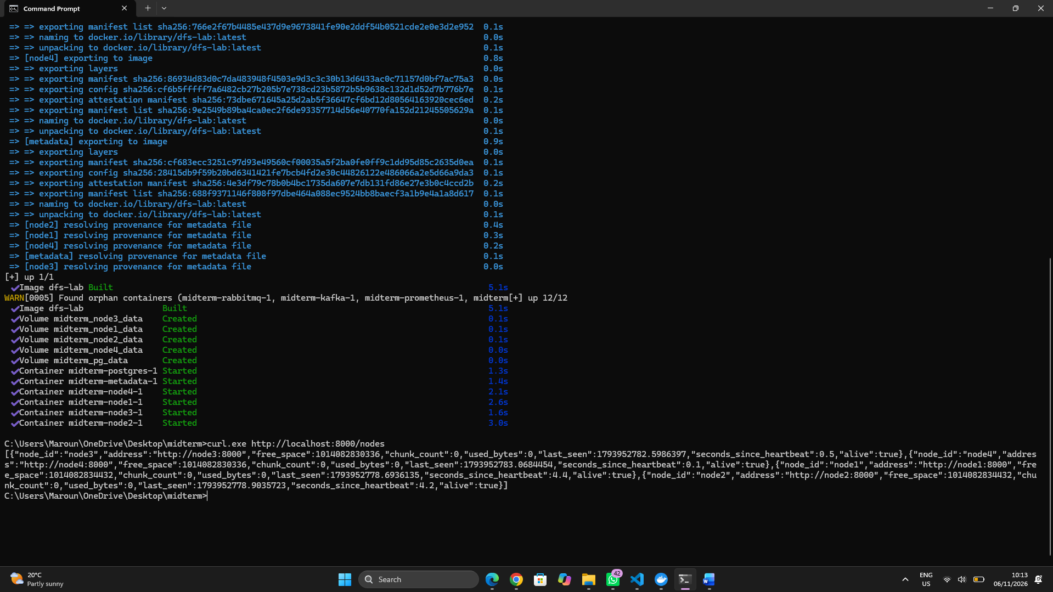

2- Redundancy configuration
- Redundancy is configured with environment variables in the metadata service.
- ec.py wraps zfec: encode() cuts a chunk into k data shards and adds m parity shards, and decode() rebuilds the chunk from any k shards.
- Each bucket has a mode, replication or ec, stored in a new buckets table.
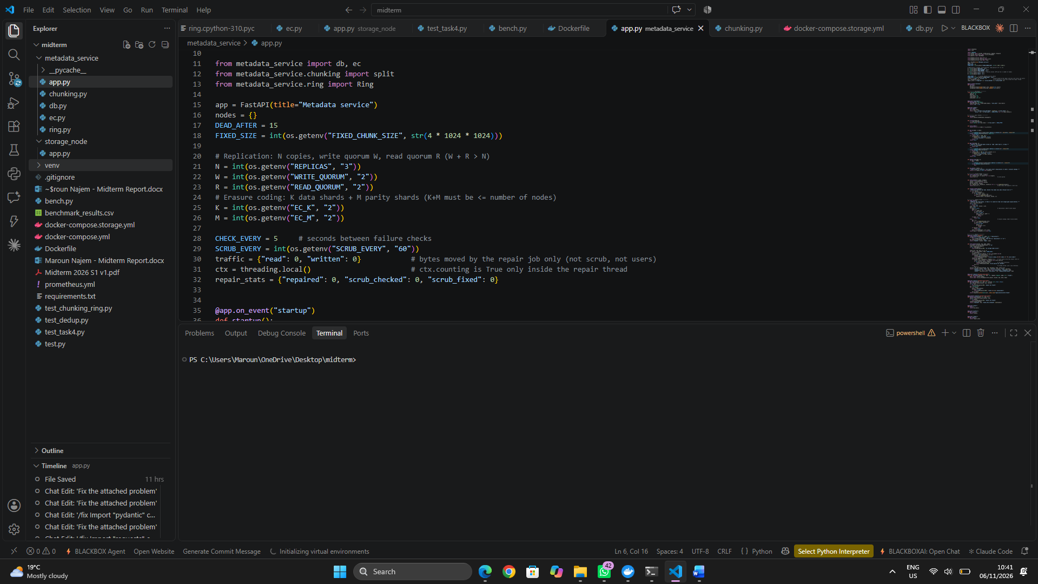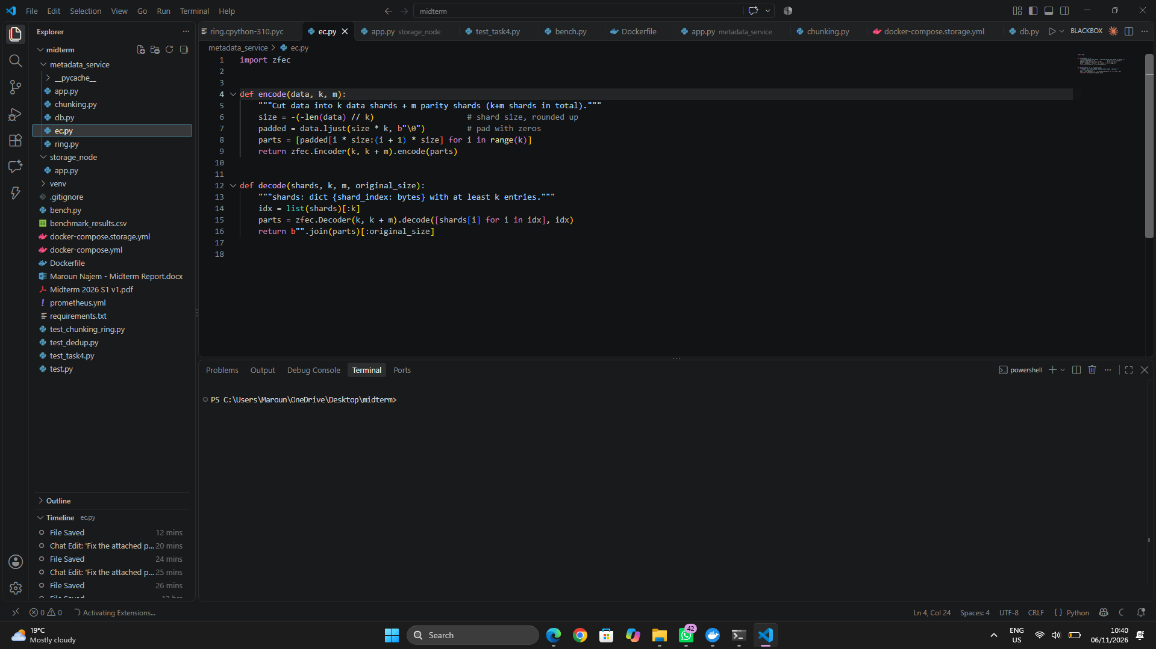

3- Upload to a replicated and an erasure-coded bucket
- I created one bucket per mode and uploaded a 9 MB object (3 chunks) to each.
- Replication bucket: each chunk is written to 3 nodes, and the write succeeds once 2 acknowledge (W=2).
- EC bucket: each chunk is encoded into 4 shards, one per node, and the write succeeds once 3 are stored.
- The nodes hold 47.2 MB for 18.9 MB of logical data, which is 3x for the replicated object and 2x for the EC object.

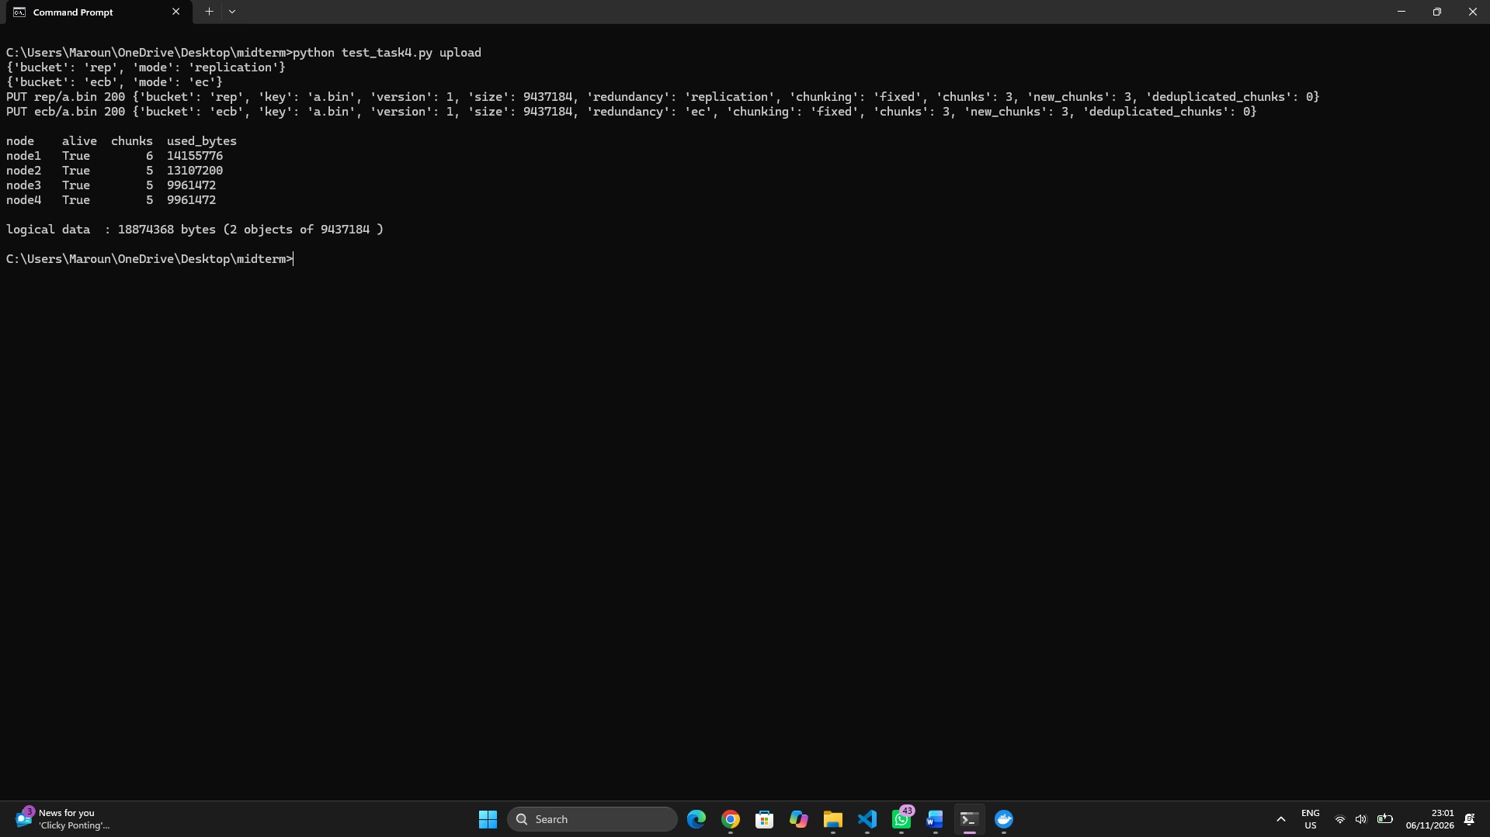

4- Reading data back
- A read fetches R=2 valid copies per chunk (replication) or any 2 valid shards and decodes them (EC).
- Every piece is re-hashed with SHA-256 and rejected if it doesn’t match.
- Both objects are identical to the originals (matches: True).\

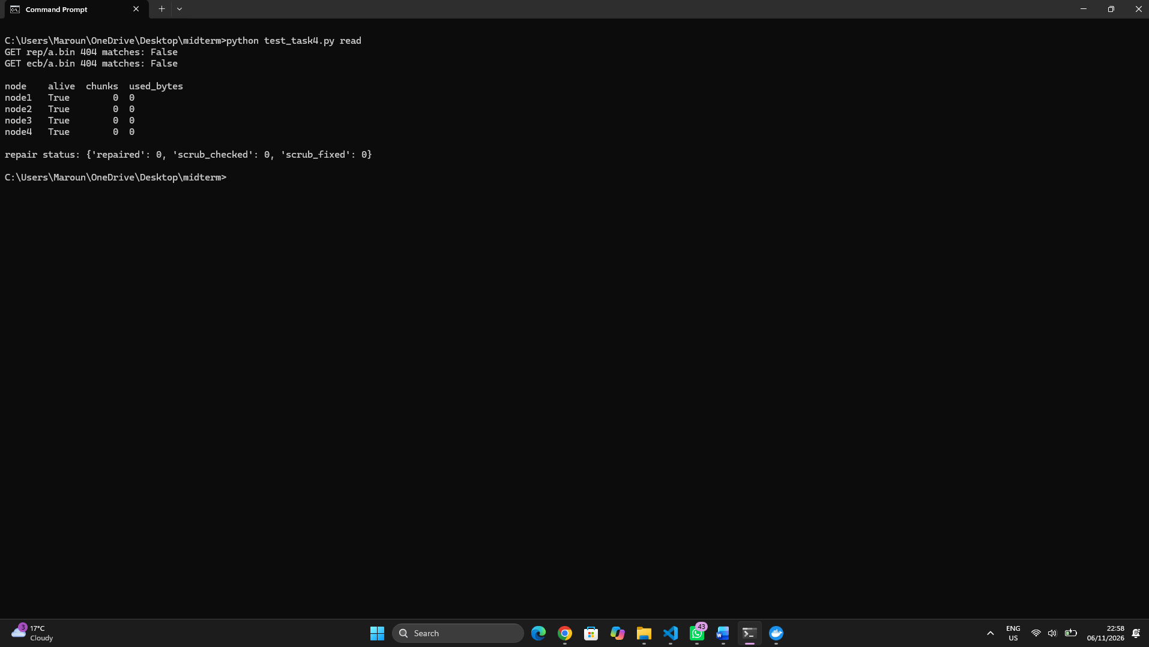

5- Node failure and repair
- I stopped node3. After 15 seconds without a heartbeat, the metadata service marks it as failed.
- Reads remain correct because 2 of 3 copies and 3 of 4 shards survive.
- A repair job then rebuilt the 5 chunks and shards that were on node3 onto the remaining nodes (repaired: 5), and the chunk counts of nodes 1, 2 and 4 grew accordingly.
- Full redundancy was restored without manual action.

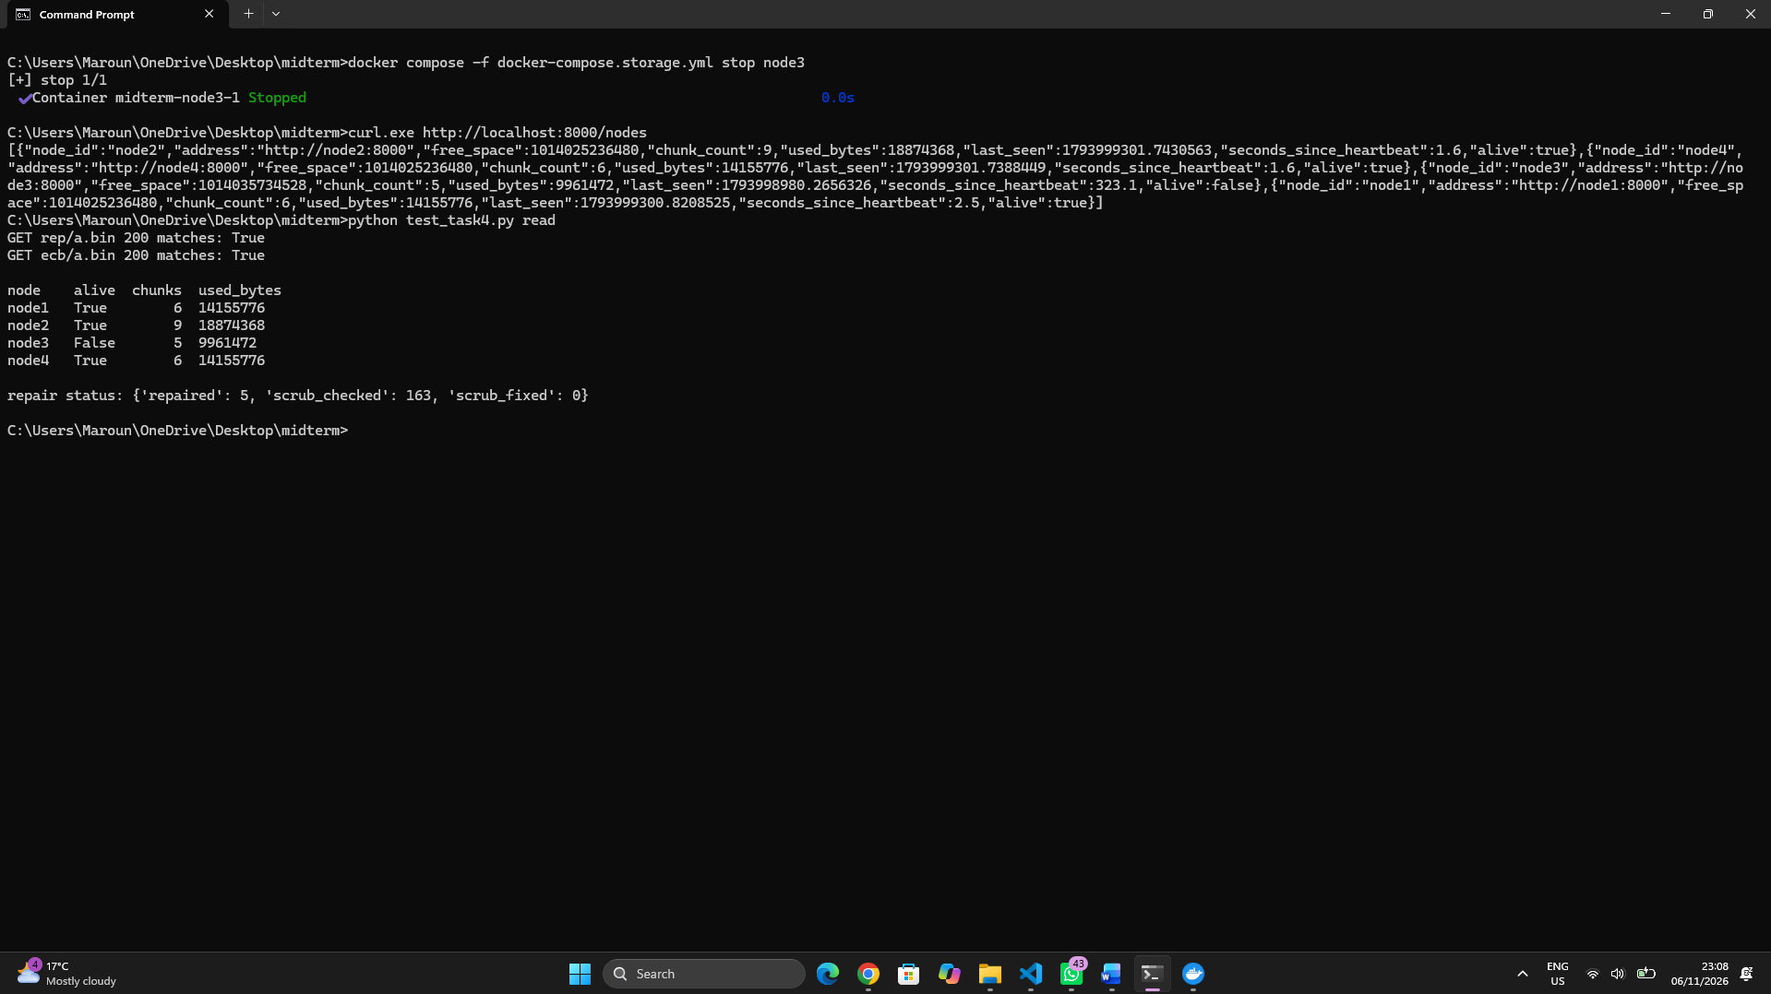

6- Scrubber
- I corrupted a chunk on node1 by appending a byte. A direct GET returned 500 chunk corrupted, because the node verifies the hash on every read.
- The background scrubber runs every 60 seconds, and I also triggered it manually.
- It re-read every chunk, detected the mismatch, deleted the bad file and rewrote it from a healthy copy. The same GET then returned 200.
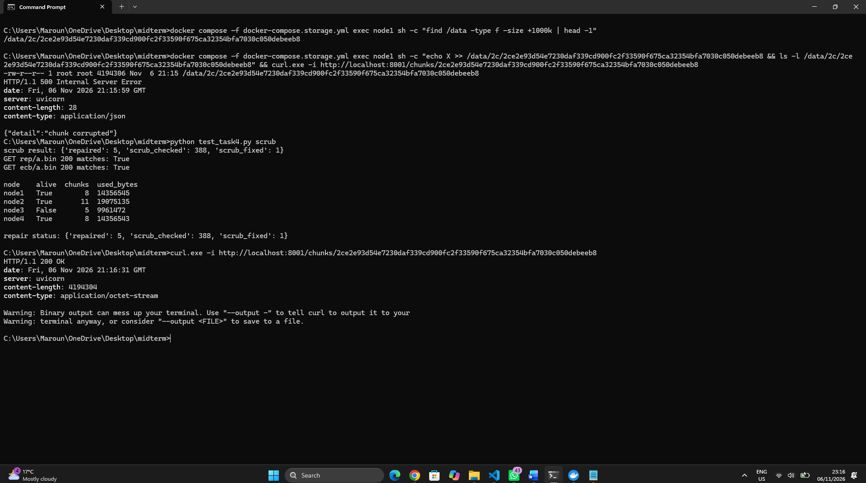

7- Benchmark: replication vs erasure coding
- I wrote a benchmark script, bench.py, that runs both workloads in both modes: 5,000 files of 1–50 KB (130.1 MB in total) and 10 files of 100 MB (1,048.6 MB).
- For each combination the script uploads the data, measures the bytes stored on all nodes, stops node3, measures the bytes moved by the repair job until the repair finishes, and then cleans up.
- The scripts that generate the datasets are part of bench.py.

Workload | Mode | Stored | Overhead | Repair traffic | Upload time | Repair time
Small (5,000 files) | Replication 3x | 390.4 MB | 3.0x | 297.0 MB | 293.6 s | 168.2 s
Small | Erasure coding 2+2 | 260.3 MB | 2.0x | 195.2 MB | 314.7 s | 214.4 s
Large (10 files) | Replication 3x | 3,145.7 MB | 3.0x | 2,403.3 MB | 58.2 s | 39.4 s
Large | Erasure coding 2+2 | 2,097.2 MB | 2.0x | 1,572.9 MB | 63.4 s | 23.2 s

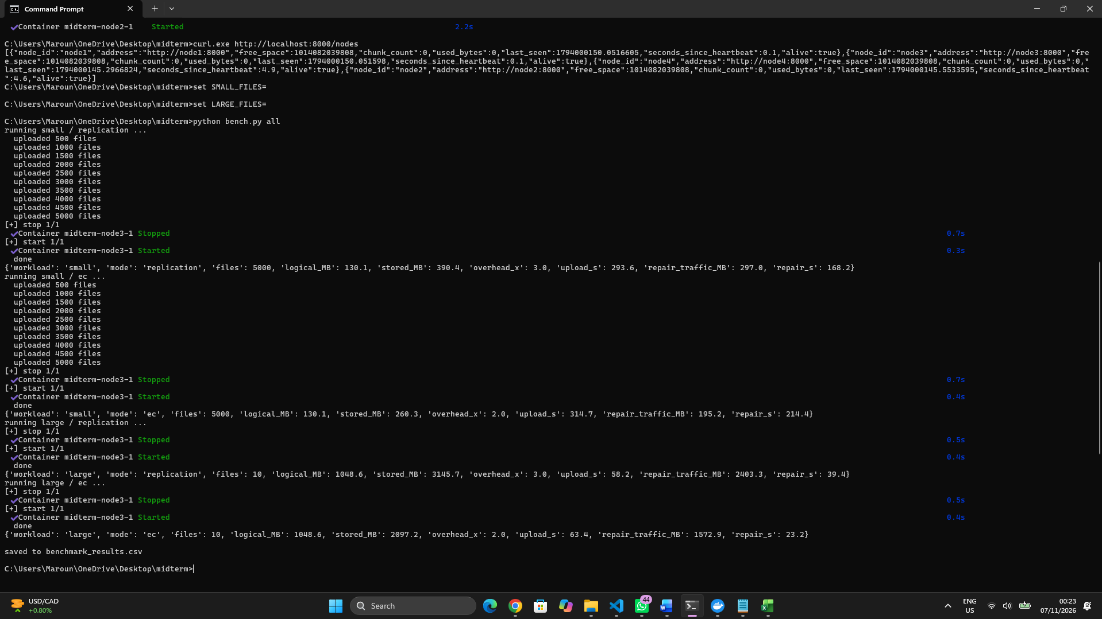



- Storage overhead: replication stores 3x the logical data and erasure coding 2+2 stores 2x, so erasure coding saves a third of the disk space on both workloads.
- Repair traffic: erasure coding moved about 34% less data to repair the failed node on both workloads (195 vs 297 MB, and 1,573 vs 2,403 MB). Replication reads 2 full copies and writes 1 copy for each lost chunk, so the traffic is about 2.25x the logical data (node3 held about three quarters of the chunks). Erasure coding reads 2 half-size shards and writes 1, which is about 1.5x.
- Performance cost: erasure coding needs CPU time to encode and decode, and it sends 4 shards per chunk instead of 3 copies. Uploads were about 7% slower for the small files and 9% slower for the large files. For the large files erasure coding repaired faster (23 s vs 39 s) because it moves less data, but for the small files it was slower (214 s vs 168 s), because thousands of tiny chunks each need several requests plus encoding. Times vary between runs, so the conclusions are based on the byte counts, which were identical across runs.
- Fault tolerance: erasure coding 2+2 survives 2 simultaneous node failures, since any 2 of 4 shards are enough to rebuild a chunk, while replication with a read quorum of 2 survives 1.
8- Challenges and limitations
- Scrub traffic counted as repair traffic: my first benchmark showed repair traffic about double the expected value, because the scrubber’s reads were counted. I changed the counter so it only counts the repair thread, and the values then matched the theory.
- Heartbeat thread dying: when a node counted its file sizes for the heartbeat while the benchmark was deleting thousands of chunks, a file could disappear mid-count, and the error stopped the heartbeat thread, so the node was wrongly considered dead. I made the counting skip deleted files and made the heartbeat loop survive any error.
- Old copies on a returning node: a node that comes back after a failure keeps its old copies, which would falsify the next storage measurement, so the benchmark now refuses to run unless the cluster is empty. Removing these stale copies is a garbage-collection job, which belongs to the bonus tasks.
- Quorum reads: a replicated chunk needs 2 valid copies to be read, so if two nodes fail at the same time before the repair runs, reads of that chunk fail until the repair finishes.
Conclusion
Replication is simpler and faster for small objects, but it costs more space and more repair traffic. Erasure coding is better for large data and for storage cost, at the price of CPU time, slower small-file repair and a minimum number of nodes.

